Consider selling your boat?
Let Current Sea Yacht Services turn your boat into Currency
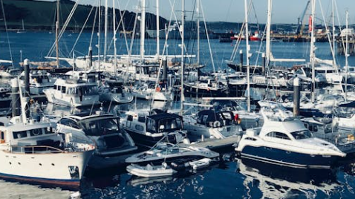

=

Current Sea Yacht Services make it easy to sell, buy or donate your yacht or boat, always with superior results that go above and beyond expectations.
Full and professional services. Marketing through a global website, signage on the boat and promoting in local publications.
Our office is located on the shores of Lake Union in Seattle, Washington. Your boat will be professionally presented by our experienced certified yacht brokers. Our team will manage the entire sales, purchase, or donation process. All legal documentation, transfer and issue of the title and ownership papers are completed by a professional and highly experienced title agency. Full trust of title and funds transfer are completed by the title and escrow company and never held by the brokerage.
Donations, all IRS forms are completed and submitted by our associated 501c3 nonprofit charity.
Please contact us today

Enter some basic boat information in the form below and our brokers will be in contact with you shortly.

Your Information
First Name *
Last Name *
Telephone
Email *

Your Boat
Make of boat :
Model of Boat:
Length:
Age
Engine hours
Location:
Overall condition:
Notes

